Functional Specifications Document (FSD) for Process Automation for Retail Loan Disbursement Project- Unity Bank

Document Revisions

|  |  |  |
| --- | --- | --- |
| Date | Version Number | Document Changes |
| 05/02/20xx | 0.1 | Initial Draft |
|  |  |  |
|  |  |  |
|  |  |  |
|  |  |  |
|  |  |  |
|  |  |  |
|  |  |  |
|  |  |  |

Approvals

|  |  |  |  |  |
| --- | --- | --- | --- | --- |
| **Role** | **Name** | **Title** | **Signature** | **Date** |
| Project Sponsor |  |  |  |  |
| Business Owner |  |  |  |  |
| Project Manager |  |  |  |  |
| System Architect |  |  |  |  |

Introduction

## Project Summary

Unity Bank aims to automate its retail loan disbursement process to reduce manual intervention, improve customer experience, and ensure compliance with regulatory requirements.

### Objectives

* Streamline loan processing with digital workflows.
* Reduce approval and disbursement time.
* Provide digital-first customer experience.
* Ensure compliance with RBI, KYC, and AML guidelines.

### Background

Currently, the process is manual and paper-heavy, requiring customers to visit branches and submit physical documents. The proposed solution introduces online loan applications, e-KYC, automated credit scoring, AML checks, and digital approvals.

### Business Drivers

* Customer demand for faster services.
* Operational cost reduction.
* Competition from fintechs.
* Digital transformation strategy.

## Project Scope

### In Scope Functionality

* Online/branch loan application submission.
* Aadhaar e-KYC.
* Credit score checks via CIBIL.
* AML blacklist check.
* Automated & manual loan approval workflow.
* Notifications to customers.
* Dashboards for bank staff.

### Out of Scope Functionality

* Corporate & mortgage loans.
* Mobile banking redesign beyond loan module.
* Third-party aggregator integrations.

## System Perspective

### Assumptions

* Corporate & mortgage loans.
* Mobile banking redesign beyond loan module.
* Third-party aggregator integrations.

### Constraints

* Dependency on external APIs.
* Must comply with RBI/AML.
* Limited budget for advanced AI features.

Business Process Overview

### Current Business Process (As-Is)

* Customer visits the bank branch to collect and fill out the paper loan application form.
* Customer submits physical documents (ID proof, address proof, income proof, etc.) along with the form.
* Loan Officer manually checks whether the submitted documents are complete.
* If documents are incomplete, the customer is asked to resubmit or provide missing information.
* Loan Officer manually verifies customer identity documents (KYC) without automated integration.
* Creditworthiness check is done manually by contacting CIBIL or similar agencies.
* AML checks are either skipped or done manually through static watchlists.
* Risk/credit review is largely manual, with little system support.
* Loan application is physically forwarded to the Bank Manager for approval.
* On approval, loan disbursement is processed manually through the bank’s core banking team.
* Customer is informed via phone calls or in-branch visits; no automated notifications are provided.

### Proposed Business Process (To-Be)

* Customer submits loan application online or at a branch (system-assisted).
* Loan Officer performs a quick preliminary document check.
* System runs automated document verification and triggers e-KYC.
* If e-KYC fails, case is routed for manual KYC verification.
* System fetches credit score and runs AML checks automatically.
* Applications flagged for issues are reviewed manually by Credit Analysts.
* Eligible applications go to Bank Manager for digital approval.
* Customer digitally signs the loan agreement (Aadhaar OTP/DigiLocker).
* Approved loans are disbursed automatically via CBS integration.
* Customer receives real-time updates at each stage via SMS and app notifications.

Functional Requirements

3.1 Loan Application Submission

This functionality enables customers to submit loan applications online or at branches. The system validates fields and confirms submission.

Acceptance Criteria:

1. The system shall allow customers to fill and submit loan application online or at a branch.
2. All required fields (Name, DOB, Aadhar number, PAN, Loan type, Loan amount, Income) must be mandatory.
3. Aadhar and PAN numbers must be validated for correct format before submission.
4. Income field must accept only positive values.
5. If required documents are not submitted, then the system should prevent from submission and show an error.
6. On successful submission, the system must display a confirmation screen and send an SMS/email to the customer.
7. Unauthenticated users must be redirected to the login page.
8. The application form should load within 2 seconds.

3.2 Automated Document Verification

This functionality enables the system to automatically scan, match, and validate documents uploaded by customers against the requirements for the selected loan product.

Acceptance Criteria:

* When the customer uploads documents, the system shall auto-scan and compare them to the expected document types for that loan product.
* If all required documents are detected and valid, the system shall display: “All documents submitted and verified.”
* If any required document is missing, invalid, or mismatched, the system shall display: “Documents missing/irrelevant document.”
* The Loan Officer shall be allowed to upload any missing documents manually on behalf of the customer.
* The system shall allow document rescanning for verification up to 3 times per application.
* After 3 unsuccessful attempts, the system shall flag the application and prompt the Loan Officer to conduct a manual document check.
* On successful document verification, the Loan Officer shall be automatically redirected to the next step in the loan processing workflow.

3.3 Preliminary Document Check (Loan Officer)

This functionality allows the Loan Officer to conduct a preliminary review of documents uploaded by the customer. The officer verifies whether all documents are uploaded, relevant, and legible before moving the application to automated system checks.

Acceptance Criteria:

1. The system shall display all uploaded documents for each application in the Loan Officer’s dashboard.
2. The Loan Officer shall be able to mark documents as either “Complete” or “Requires Customer Action”.
3. If a document is missing, invalid, or unclear, the system shall prevent the application from moving forward and automatically send a notification to the customer to re-upload the required documents.
4. If all documents are marked as “Complete”, the system shall automatically route the application to the Automated Document Verification process.
5. The system shall record all actions performed by the Loan Officer, including marking documents, remarks (if entered), date, time, and user ID, in the audit log.

**3.4 e -KYC Verification**

This functionality allows the system to automatically verify the customer’s identity using Aadhaar e-KYC. This minimizes manual verification efforts and ensures regulatory compliance.

**Acceptance Criteria:**

1. Once document verification is completed, the system shall automatically trigger the Aadhaar e-KYC process.
2. The system shall send the customer’s Aadhaar details to the UIDAI e-KYC API and fetch the verification response.
3. The e-KYC response shall be displayed to the Loan Officer within **5 seconds** (target), with a maximum acceptable delay of **10 seconds**.
4. If e-KYC verification is successful, the system shall update the application status to **“KYC Verified”** and proceed to the Credit Score Check.
5. If e-KYC verification fails, the system shall route the application to the **Manual KYC Verification** process.
6. The system shall allow a maximum of **3 retry attempts** for e-KYC before mandating manual verification.
7. The system shall log the e-KYC status (Successful/Failed), the number of attempts, timestamp, and transaction reference in the applicant’s record.

**3.5 Manual KYC Verification**

This functionality enables KYC Analysts to manually verify customer identity documents when e-KYC fails or is unavailable.

**Acceptance Criteria:**

1. The system shall allow KYC Analysts to view and validate all uploaded identity and address proof documents.
2. The Analyst shall be able to mark the status as either **“Verified”** or **“Rejected”**, along with mandatory remarks.
3. If the application is rejected, the system shall notify the customer immediately and close the loan application.
4. If the application is verified, the system shall update the status to **“KYC Verified”** and proceed to the Credit Score Check step.
5. All actions taken by the KYC Analyst shall be logged with date, time, user ID, and remarks.

**3.6 Credit Score Check**

This functionality enables the system to fetch the applicant’s credit score from CIBIL for creditworthiness assessment.

**Acceptance Criteria:**

1. The system shall automatically send the customer's basic details (Name, PAN, DOB, etc.) to the CIBIL API to fetch the credit score.
2. The system must fetch and display the score within **5 seconds (target)**, with a maximum acceptable delay of **10 seconds**.
3. If the credit score is **≥ 700**, the application shall proceed to the next step automatically.
4. If the credit score is **below 700**, the system shall flag the case for manual review.
5. If CIBIL returns a null, timeout, or invalid response, the system shall retry once and then notify the Loan Officer for manual action.
6. The fetched credit score shall be displayed in the Loan Officer’s and Credit Analyst’s dashboards in **read-only format** and stored securely in the applicant’s profile.

**3.7 AML Check**

This functionality allows the system to check applicant details against predefined Anti-Money Laundering (AML) blacklists to ensure compliance and detect potential fraud.

**Acceptance Criteria:**

1. The system shall check the applicant’s name and PAN against predefined AML blacklists.
2. If no match is found, the system shall display **“No AML issues detected”** and allow the application to proceed.
3. If a match is found, the system shall display **“AML Match Found – Review Required”** and block the application from moving forward until manually reviewed.
4. The system shall record the AML check result and timestamp in the applicant’s record.

**3.8 Manual Credit and Risk Review**

This functionality allows Credit Analysts to review loan applications flagged due to low credit score, high debt-to-income ratio, or AML concerns.

**Acceptance Criteria:**

1. The system shall check if the customer’s income-to-loan ratio exceeds **50%** and flag the application if it does.
2. If the credit score is below **700**, the system shall mark the application as **“High Risk – Credit Score”**.
3. Flagged applications shall appear in the **“Review Required”** queue in the Credit Analyst’s dashboard.
4. The Credit Analyst shall be able to take one of three actions: **Reviewed & Approved**, **Approved with Exceptions**, or **Rejected**.
5. Rejection or approval with exceptions shall require mandatory remarks to be entered by the Credit Analyst.
6. All actions shall be logged with timestamp, analyst ID, and remarks.

**3.9 Bank Manager Approval**

This functionality allows the Bank Manager to review, approve, reject, or send back loan applications after analyst review.

**Acceptance Criteria:**

1. Once the customer has digitally signed the loan agreement, the system shall:
   * Display an approval alert on the Bank Manager's dashboard.
   * Send an email notification with a link to the application.
2. The Bank Manager shall access the application by either:
   * Clicking the dashboard alert or email link.
   * Opening the **“Pending Approvals”** tab in their dashboard.
3. The application view shall include:
   * Summary of loan details.
   * Customer information.
   * Loan Officer or Analyst remarks (if any).
   * A button to download the sanction letter.
4. Below the application details, the system shall display three action buttons: **Approve**, **Reject (with remarks)**, or **Send Back for Clarification (with optional remarks)**.
5. On clicking **Approve**, the system shall:
   * Trigger the Loan Disbursement workflow.
   * Update the application status to **“Approved for Disbursement”**.
6. On clicking **Reject**, the system shall:
   * Require remarks.
   * Update the status to **“Rejected by Manager”**.
   * Notify the customer immediately by SMS and email.
7. All Manager actions shall be logged with timestamp, user ID, and remarks.

**3.10 Digital Agreement Signing (Aadhar OTP/ DigiLocker)**

This functionality enables customers to digitally sign loan agreements using Aadhaar OTP or DigiLocker authentication.

**Acceptance Criteria:**

1. The system shall display two buttons on the agreement signing screen: **“Sign using Aadhaar OTP”** and **“Sign using DigiLocker”**, allowing the customer to select a signing method.
2. For Aadhaar OTP signing:
   * The system shall prompt the customer to enter their 12-digit Aadhaar number.
   * An OTP shall be sent to their registered mobile number.
   * The OTP must be entered within **2 minutes** and verified successfully.
3. For DigiLocker signing:
   * The system shall redirect the customer to the DigiLocker login page.
   * Upon successful authentication, the system shall fetch the digital signature and apply it to the loan agreement.
4. Upon successful signing (via either method), the system shall:
   * Update the agreement status to **“Digitally Signed”**.
   * Store the signing method and timestamp in the loan record.
5. If signing fails or is cancelled, the system shall display: **“Signature failed or cancelled. Please try again or contact support.”**

**3.11 Loan Disbursement**

This functionality enables the system to disburse approved loans directly to the customer’s bank account using Core Banking System (CBS) integration.

**Acceptance Criteria:**

1. Once the loan agreement is digitally signed and approved, the system shall initiate disbursement via CBS API.
2. The system shall send the approved loan amount, customer account number, IFSC, and transaction details to the CBS for processing.
3. If the disbursement is successful, the system shall update the loan status to **“Disbursed”** and store the CBS transaction ID in the application record.
4. If the disbursement fails, the system shall retry automatically up to **3 times**. If it still fails, the system shall mark the status as **“Disbursement Failed”** and alert the Loan Officer.
5. The system shall send an SMS and email notification to the customer with the disbursement details, including loan amount, credited account, and transaction ID.
6. All disbursement attempts, whether successful or failed, shall be recorded in the system logs with timestamp, transaction reference, and status.

**3.12 Notifications**

This functionality enables the system to send real-time updates to customers at key stages of the loan lifecycle.

**Acceptance Criteria:**

1. The system shall send real-time SMS and app notifications at key loan stages (e.g., application submitted, KYC verified, approved, disbursed).
2. Each notification shall include a short status message and the loan/application reference number.
3. Notifications must be sent within **10 seconds** of the corresponding event.
4. If SMS delivery fails, the system shall retry delivery up to **2 times** before marking as failed.
5. All delivery attempts and outcomes shall be logged in the system.
6. Customers shall be able to view their complete notification history under: **App → My Loans → Loan Updates**.

4.Non-Functional Requirements

|  |  |  |
| --- | --- | --- |
| NFR ID | Category | Requirement |
| NFR-01 | Performance | The system shall process and disburse approved loans within 8 hours of submission. |
| NFR-02 | Availability | The system shall be available 99.9% of business hours. |
| NFR-04 | Security | End-to-end encryption for data at rest and in transit. |
| NFR-05 | Access Control | Role-based access for customer and loan data. |
| NFR-06 | Auditability | Timestamped logs for all critical actions. |
| NFR-07 | Compliance | Compliance with RBI, KYC, AML guidelines. |
| NFR-08 | Usability | Loan application completion within 5 minutes without external help. |
| NFR-11 | Notification | Real-time notifications via SMS and email for status changes. |

5.Data Dictionary

**Data Requirements**

|  |  |  |  |  |
| --- | --- | --- | --- | --- |
| Field Name | Description | Type | Mandatory | Validation Rules |
| Name | Applicant’s full legal name | String | Yes | Alphabets + spaces only; Max 100 chars |
| DOB | Date of birth | Date | Yes | Age ≥ 18 |
| Aadhaar No. | 12-digit unique ID | Numeric | Yes | Exactly 12 digits, valid checksum |
| PAN | Tax ID | String | Yes | 5 letters + 4 digits + 1 letter |
| Loan Type | Loan category | Enum | Yes | Predefined dropdown |
| Loan Amount | Requested amount | Decimal | Yes | ₹10,000–₹50,00,000 |
| Annual Income | Yearly income | Decimal | Yes | ≥ ₹1,00,000 |
| Documents | Proofs (ID, Address, Income) | File | Yes | Max 5 MB each |
| Application Date | Submission date | DateTime | Auto | Read-only |
| Application Status | Workflow stage | Enum | Auto | E.g., Submitted, Approved |
| Credit Score | From CIBIL | Integer | Auto | 300–900 |
| Risk Flag | System-calculated | Enum | Auto | High Risk, Eligible |
| Remarks | Analyst comments | String | Optional | Max 500 chars |

6.Glossary

* KYC: Know Your Customer
* AML: Anti-Money Laundering
* CIBIL: Credit Information Bureau (India) Limited
* CBS: Core Banking System
* OTP: One Time Password

7.Appendix

7.1 Process Diagrams

7.1.1 AS-IS Process Diagram

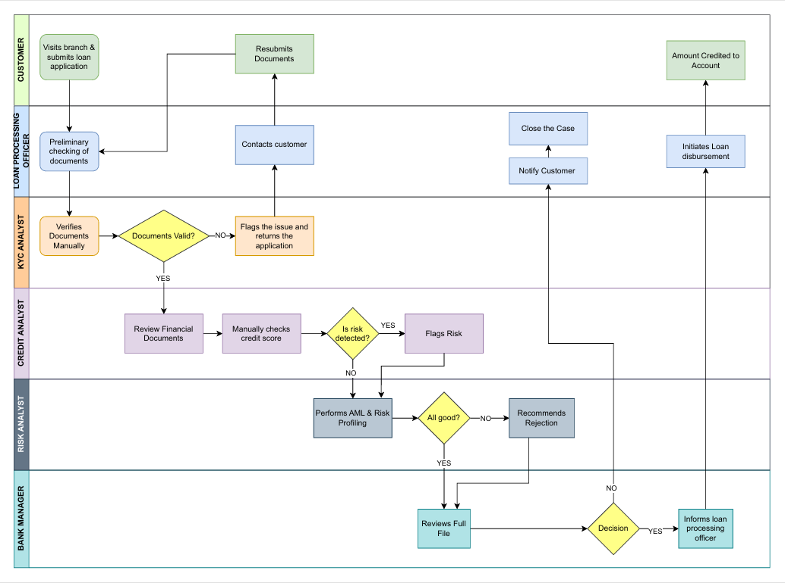

7.1.2 TO-BE Process Diagram

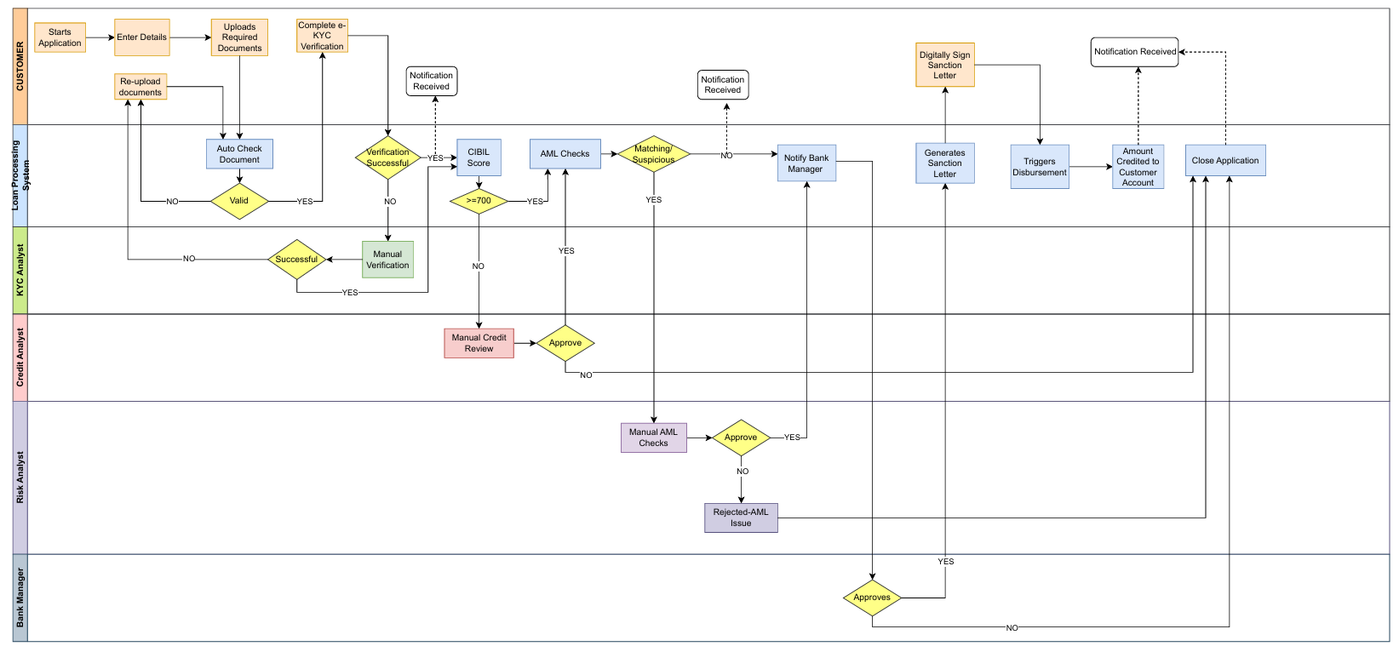

7.2 Wireframes

7.2.1 Customer Details Screen

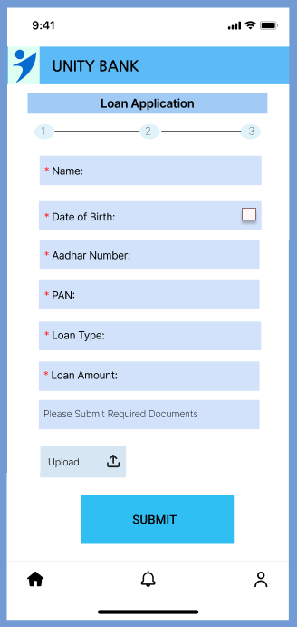

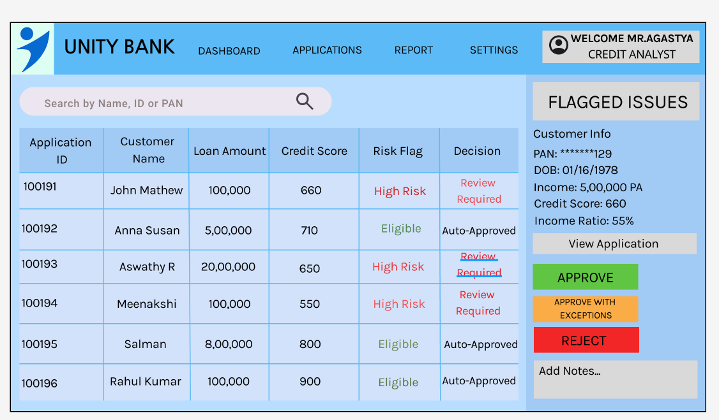7.2.2 Credit Analyst Dashboard

7.2.3 Agreement Signing Screen

